1. COUNT() – Count number of rows
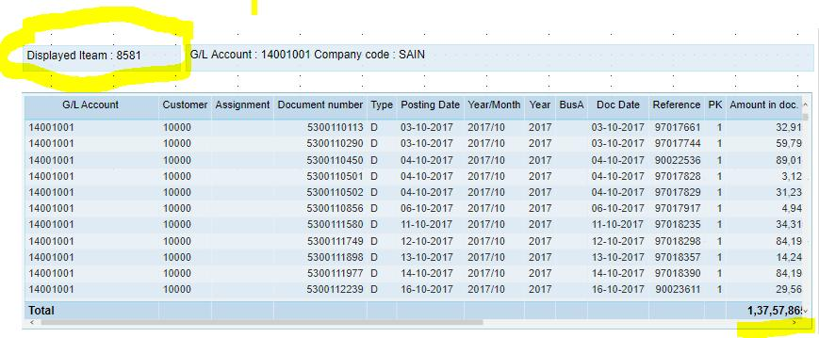


6
COUNT(*)
Counts all rows in a table
SELECT COUNT(*)
FROM movies;
Example output:
53
Meaning → there are 53 movies in table.

COUNT(column)
Counts only rows where column is NOT NULL
SELECT COUNT(movie_lang)
FROM movies;

COUNT(DISTINCT column)
Counts only unique values
SELECT COUNT(DISTINCT movie_lang)
FROM movies;
Example:
movie_lang values
English
English
English
French
French
Result:
2

COUNT with condition (WHERE)
Count only English movies
SELECT COUNT(*)
FROM movies
WHERE movie_lang='English';

COUNT(*) vs COUNT(1)
Both count rows:
SELECT COUNT(*) FROM movies;
SELECT COUNT(1) FROM movies;
Both give same result.
Best practice → use COUNT(*)

2. SUM() – Add numbers



6
Used only for numeric columns.
Example table
movies_revenues:
movie_id | revenue_domestic
1 | 100
2 | 200
3 | 300

Total revenue
SELECT SUM(revenue_domestic)
FROM movies_revenues;
Output:
600

SUM with condition
Total revenue where revenue > 200
SELECT SUM(revenue_domestic)
FROM movies_revenues
WHERE revenue_domestic > 200;

SUM with DISTINCT
Removes duplicate values
SELECT SUM(DISTINCT revenue_domestic)
FROM movies_revenues;

Important Rule
SUM works only on numbers ❌
Wrong:
SELECT SUM(movie_name)
FROM movies;
Error → because movie_name is text

3. MIN() and MAX()
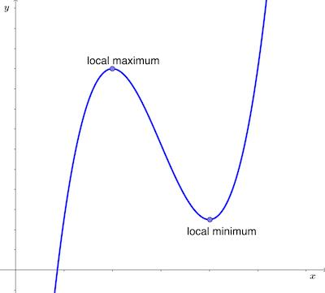
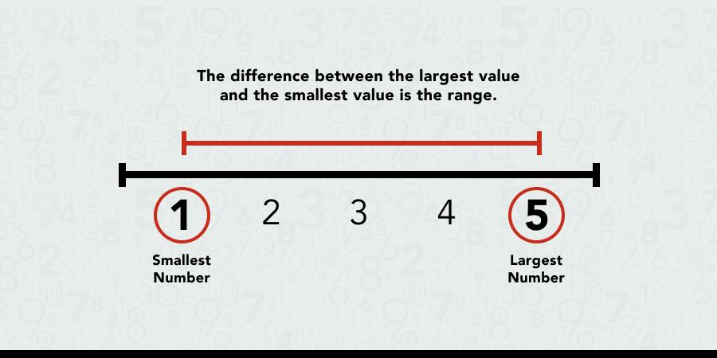
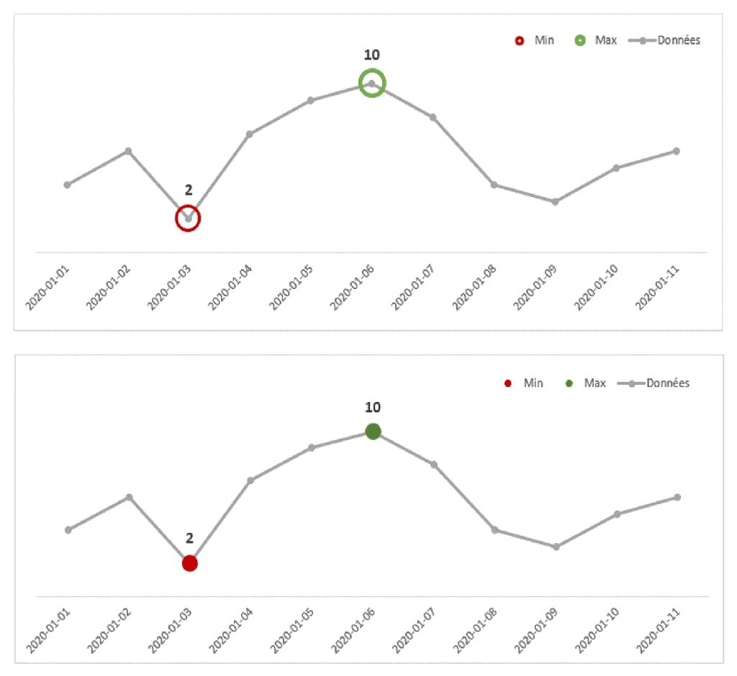
5
Find smallest or largest value.

Maximum movie length
SELECT MAX(movie_length)
FROM movies;
Example output:
168

Minimum movie length
SELECT MIN(movie_length)
FROM movies;
Example:
87

With condition
Longest English movie:
SELECT MAX(movie_length)
FROM movies
WHERE movie_lang='English';

Using with dates
Latest movie release:
SELECT MAX(release_date)
FROM movies;
Oldest movie:
SELECT MIN(release_date)
FROM movies;

MIN and MAX also work with text
Example:
SELECT MAX(movie_name)
FROM movies;
Result:
last alphabetically.
Example:
Zootopia

4. GREATEST() vs MAX()
MAX()
Find max value from column
SELECT MAX(movie_length)
FROM movies;

GREATEST()
Compare multiple values
SELECT GREATEST(10,50,30);
Output:
50

Difference:
Function | Works on
MAX | column values
GREATEST | list of values

5. Mathematical Operators

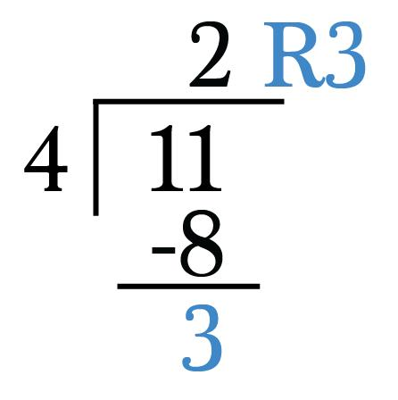

4
PostgreSQL supports math operations:
operator | meaning
+ | addition
- | subtraction
* | multiplication
/ | division
% | modulus (remainder)

Addition
SELECT 2 + 10;
Output:
12

Subtraction
SELECT 10 - 2;
Output:
8

Multiplication
SELECT 2 * 10;
Output:
20

Division
SELECT 10 / 2;
Output:
5
Decimal result:
SELECT 10::numeric / 3;
Output:
3.3333

Modulus (remainder)
SELECT 15 % 2;
Output:
1
Because:
15 ÷ 2 = 7 remainder 1

6. Mathematical operations on columns
Example:
total movie revenue
SELECT
movie_id,
revenue_domestic,
revenue_international,
revenue_domestic + revenue_international AS total_revenue
FROM movies_revenues;

Handling NULL values
If one column is NULL:
100 + NULL = NULL
Remove NULL rows:
SELECT *
FROM movies_revenues
WHERE revenue_domestic IS NOT NULL;

Quick Summary
Function | Purpose
COUNT | number of rows
SUM | total value
MIN | smallest value
MAX | largest value
GREATEST | largest from list
+ | addition
- | subtraction
* | multiplication
/ | division
% | remainder

